DBC2
ENKO MODBUS TOOL
USER MANUAL
V1003

ENKO Battery Charger Team
March 2023
Contents
1. Connecting to Device 3
2. Reading Output Values 4
Readable Parameters 4
Warning And Error Outputs 5
3. Configuring Output Values 6
Settable Parameters 7
4. Updating Firmware 8
5. Logging Info 9
6. UI Theme 9

ENKO Modbus Tool provides interface to the DBC2 device over USB. Using this interface following actions can be taken.

1. Connecting to Device

This tool uses modbus over USB to talk with the device. To use it:
- First connect USB from device to PC.
- Then click on Connect/Disconnect toggle.
- Values should be updated on the UI. If not please check the connections and drivers.
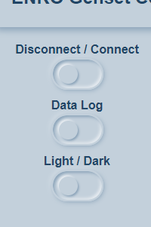Image 1

2. Reading Output Values
This tool can show you output readings in UI.
Vout is the output Voltage readed from Modbus interface and Iout is the output current. Their units are Volts and Amps accordingly.

Examples:

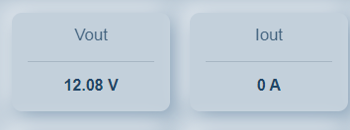Image 2

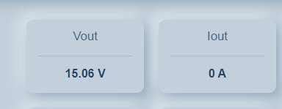Image 3

Readable Parameters
There are few monitoring parameters to see device states and readings. There are few examples below. More information about these monitoring parameters can be found on “Parameter Lists Vxxx” document.
- Vout, Iout, Vbat.
- NTC, RPT100.
- Error and Warning Flags.
- SW Version.
Also all of the settable parameters can be monitored simultaneously.

Warning And Error Outputs
There is 5 warning situations and 3 error situations for this device. They are visually represented by diagram in Modbus Tool. If any one of them goes to red color this means there is corresponding error happening right now on device.

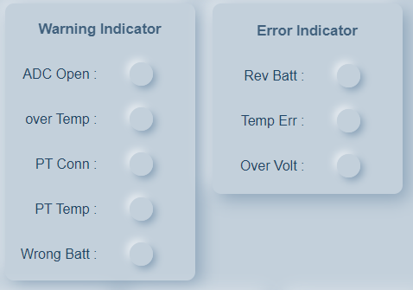Image 4

3. Configuring Output Values

Output voltage can be controlled with Modbus interface through Vout-set card. Left clicking this card will open a popup window.

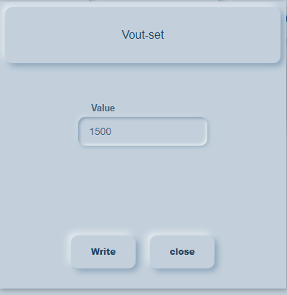Image 5

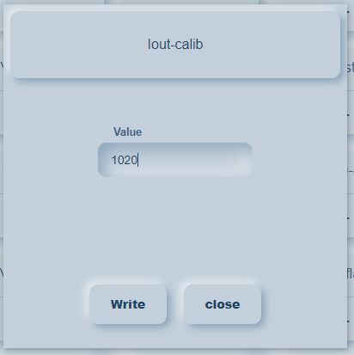Image 6

To set output voltage, desired value * 100 should be entered to value box. For example; setting to 12V could be done with 1200. Setting to 13.8V could be done with 1380 value.

Be careful, for the 75W model minimum settable output voltage is 12V and maximum settable output voltage is 15V. Only 1200 – 1500 range can be typed in this box. Otherwise input will be discarded.
After that click on the write button to send value to device. This will trigger an event and if write successful, value can be read back from this card. Otherwise card value won’t change.
After setting V or I out, device will calculate corresponding output power. If this power exceeds device limits, last set value will remain unchanged but complementary one will go for smallest possible value.

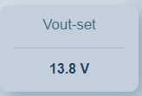Image 7

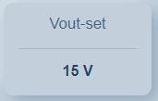Image 8

Settable Parameters
Following parameters can be also settable by this. More information about these parameters can be found on “Parameter Lists Vxxx” document.
- Iout-set.
- Vboost-set.
- isParallel
- Vout, Iout, PT100, NTC, Vbat Calibrations.
- PT100 Activated.
- PSU mode activated
- LED Color, Blink and Period controls.

4. Updating Firmware

Firmware update to the device could be done with this tool. Only ENKO firmware, and firmware files are supported.
To use this, click on the “Firmware Update” toggle on left panel. This will open a file manager window to manage firmware file. Locate the firmware file and choose it. After clicking open, update will take some time and your device’s LED’s may flicker few times. If update successful popup will show the output.
Update process should be robust and shouldn't require any user interaction on process. But if it stuck or any external interrupt disturbs update, device can go brick mode. In this case just close Modbus Tool, unplug and plug USB cable then start update process again. It would update just regularly and parameters should not be lost.
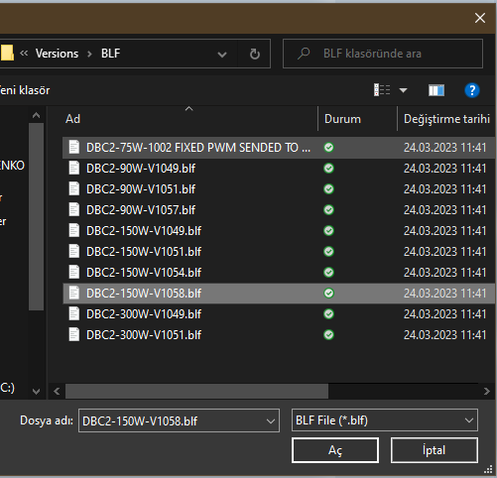Image 9
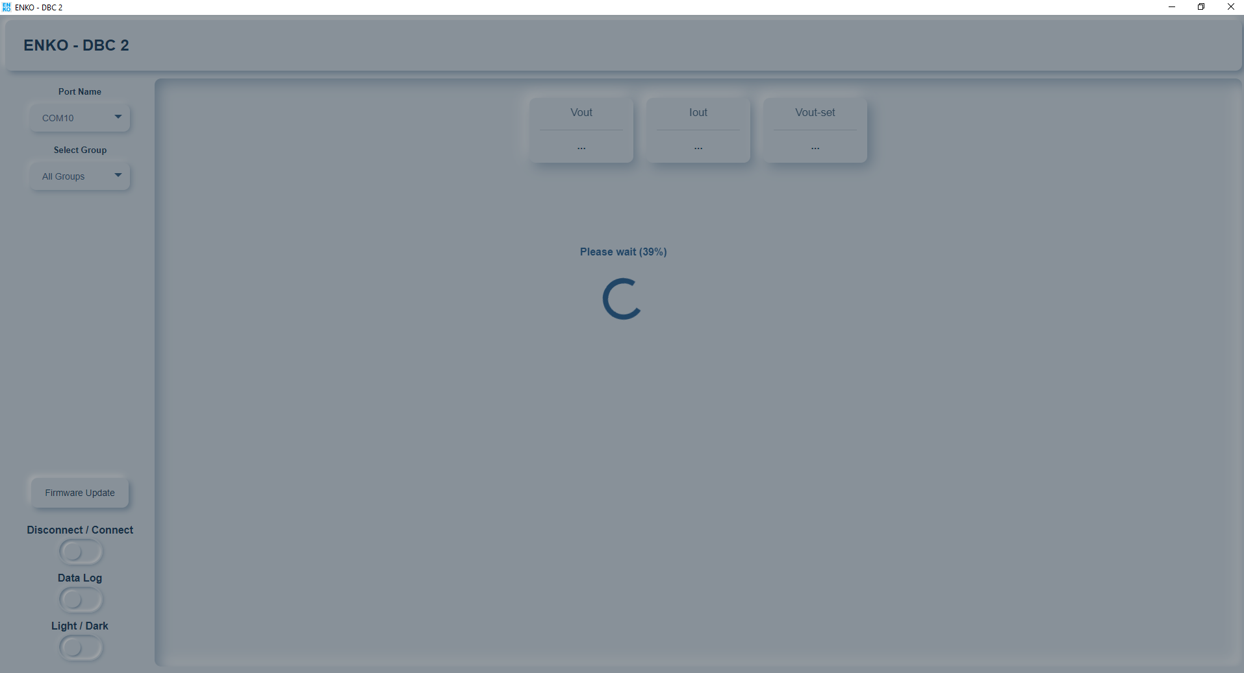Image 10

5. Logging Info

Logging of the output values versus time could be done with this tool.
To use this click on the Data Log toggle left on your panel. This will open a file manager window. Choose file name and path to save output file. This text file will contain modbus address and value of each card on UI, and will be updated every second.

6. UI Theme
User can choose to see Light or Dark theme easily through toggle switch on left plane.
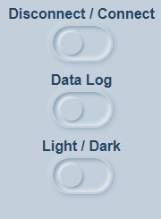Image 11

